LAB NO: 5

LAB AIM: To implement K-Nearest Neighbor (KNN) algorithm for Classification and Regression.
DATASET AND RESOURCES : diabetes_dataset from classroom and Python/Jupyter Notebook

DATE OF PERFORMANCE:17 - 09 -2026

GITHUB REPO LINK :
https://github.com/Prabhkirat-Singh-Marwah/ML-PRACTICALS/tree/main/Practical-05
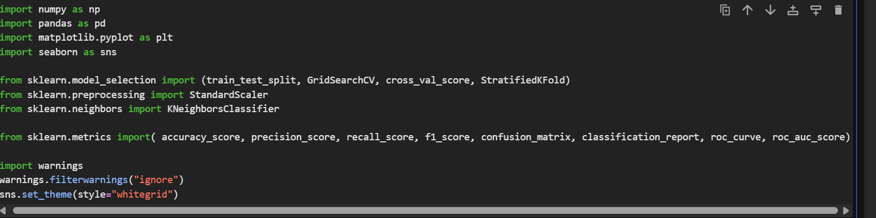
This command imports all the basic libraries needed to run our program and code cells.

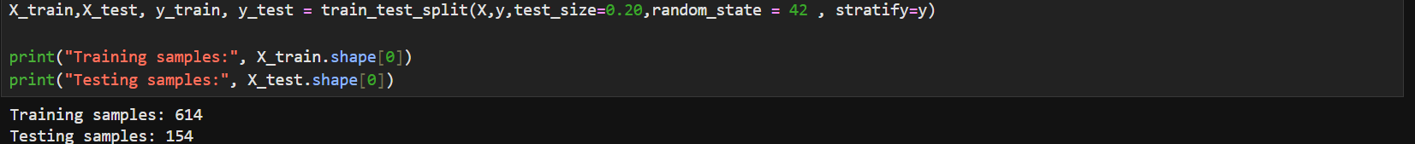
This command divides the dataset into two parts as testing and training split into 20 and 80 ratio.

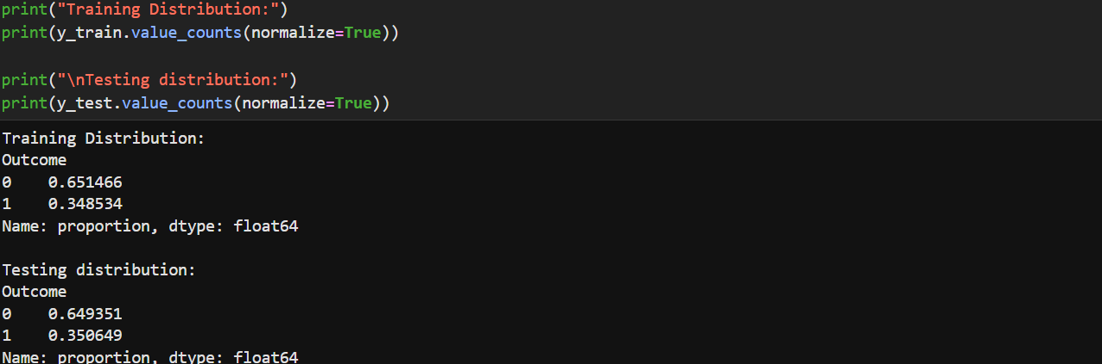
This command prints the normalized values of the outcomes from the training and testing split distribution we did above.

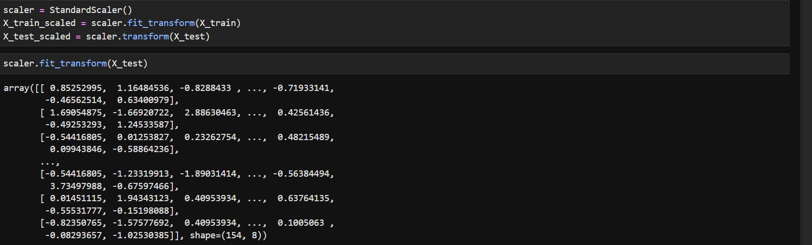this command makes all values lie in similar range so that no value overpowers other while the model is predicting and thus no biased prediction is made.

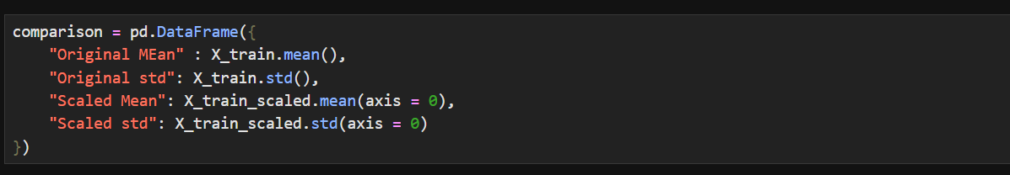
This command builds a table to compare the values before and after knn is applied to see the prediction is more or less accurate before and after knn is applied.

Here we chose k=5 means 5 neighbour will be chosen for final prediction.

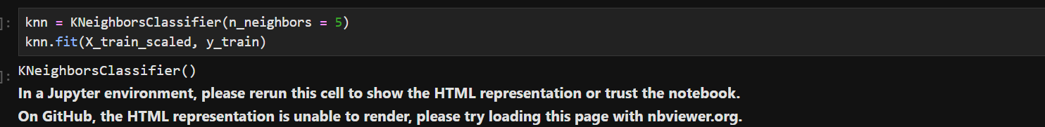
We create a KNN model that checks the 5 closest points and goes with the majority.

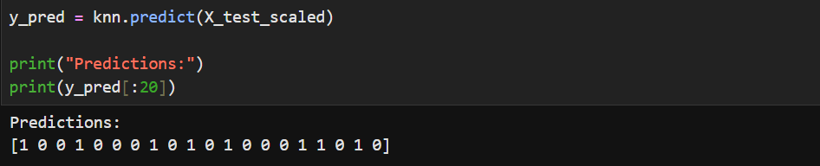
This command prints the 20 predicted values of Y that is our input column , we made scaler earlier that diabetes means 1 and no means 0.

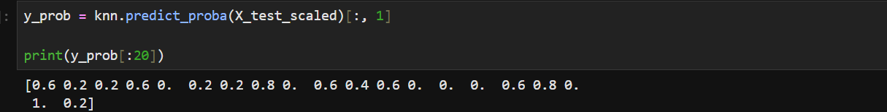
This gives the chance (0 to 1) that each patient has diabetes.
For example, 0.8 means 4 of the 5 neighbours had diabetes.

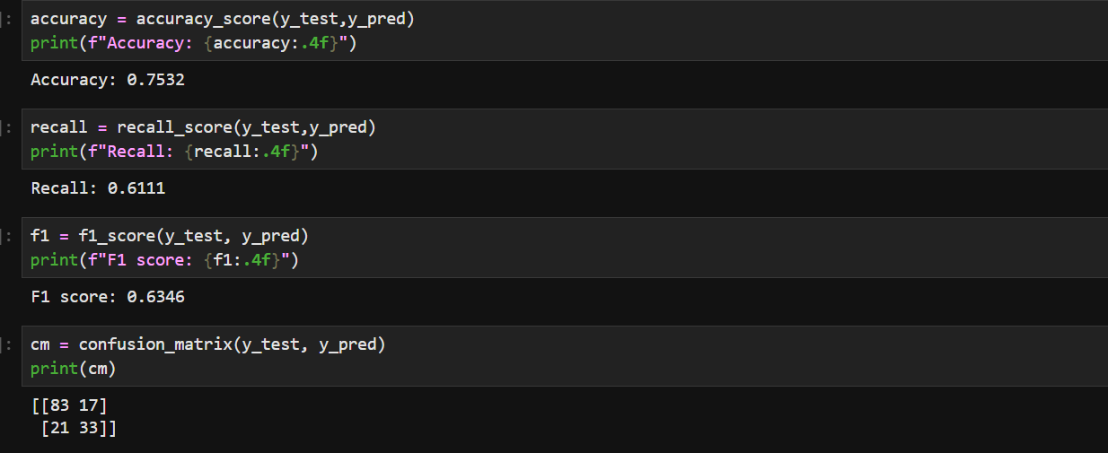
These command prints metrics like f1 score, accuracy and recall for checking if our model prediction was good or not or whether it had any biased nature in prediction or not.

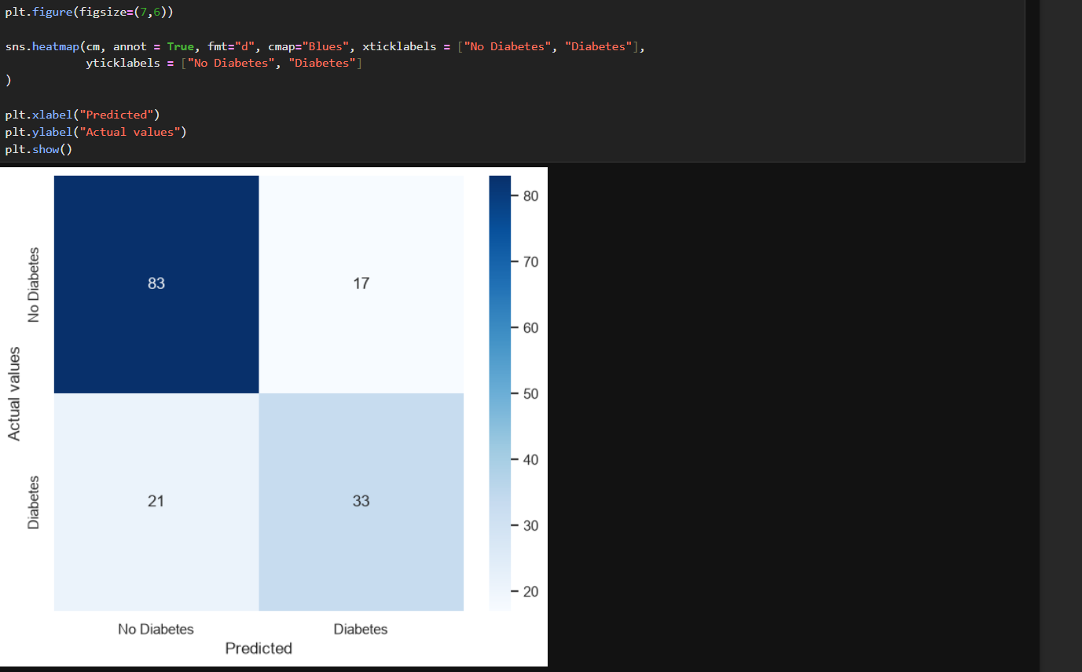
This command prints a heatmap for relation between diabetic and non diabetic person

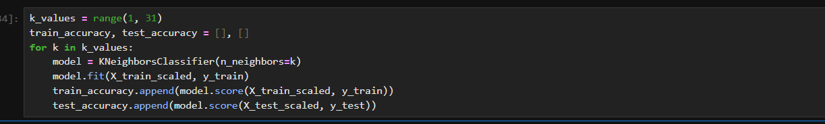

This loop trains a new KNN for every K from 1 to 30 and saves its train and test accuracy.
It helps us find which K works best.

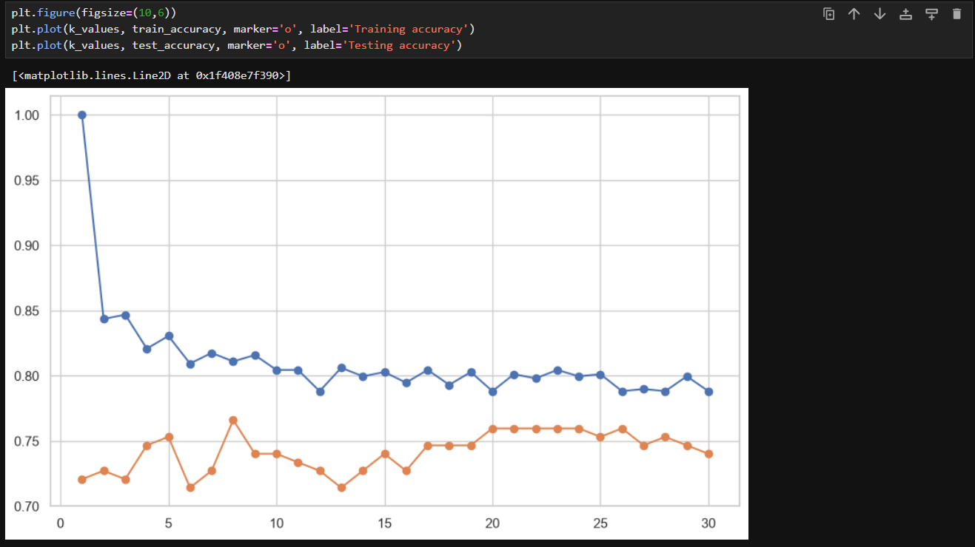

This draws two lines showing how accuracy changes as K changes.
If training is much higher than testing, the model is overfitting .

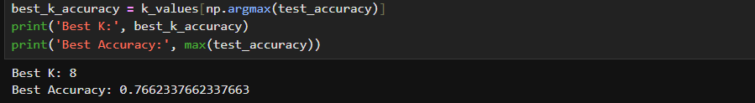
This finds the K that gave the highest test accuracy and prints it.
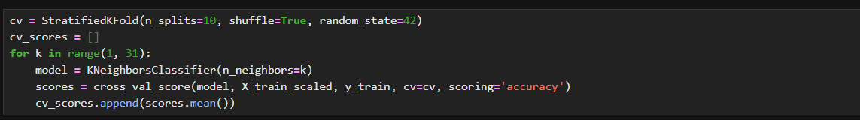
The training data is cut into 10 parts, and the model is trained on 9 and tested on 1, repeated 10 times for each K.
The average of these 10 scores is a fairer score than one single test.

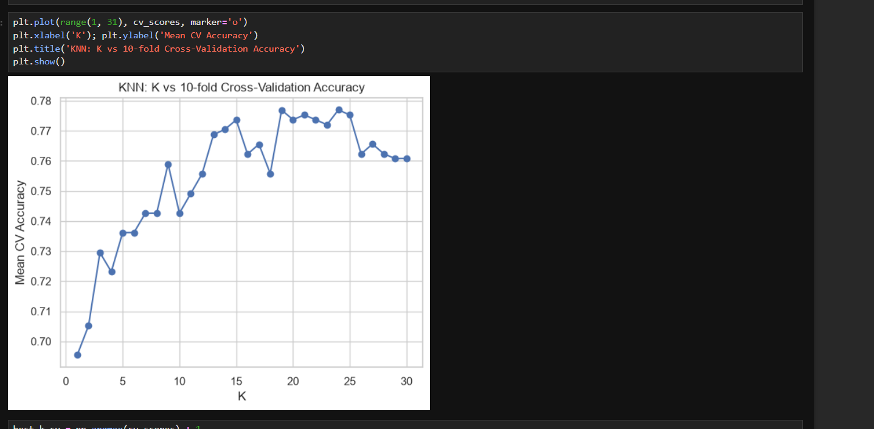
This command draws a line graph of average accuracy for each K.
The highest point on the line is the best K.

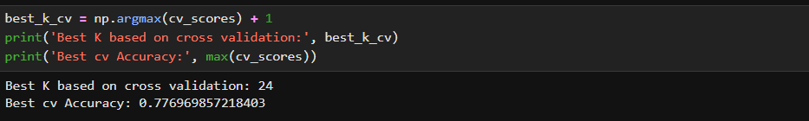

this finds the K with the highest average CV accuracy.
We add +1 because list positions start at 0 but our K starts at 1.

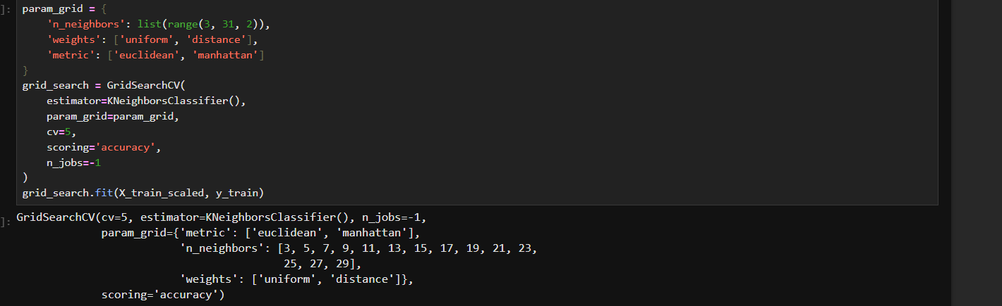

This tries every combination of K, weights, and distance type, testing each with 5-fold CV.

This prints the best combination of settings and its accuracy.

VIVA QUESTIONS
Q1. What does stratify=y do in train_test_split?
It keeps the same ratio of 0s and 1s (Outcome) in both the train and test sets. Without it, one set could end up with too few diabetes cases.

Q2. What does random_state=42 do?
It fixes the random shuffle so you get the same split every time you run the code. Without it, the results would change on each run.

Q3. What is the difference between fit(), transform(), and fit_transform() in StandardScaler?
fit() learns the mean and std, transform() applies them to data, and fit_transform() does both in one step. We use fit_transform on training data and only transform on test data.

Q4. What does cross_val_score(model, X_train_scaled, y_train, cv=cv, scoring='accuracy') return?
It returns an array of 10 accuracy scores, one for each fold of the 10-fold split. We take .mean() of these to get one average score per K.

Q5. Why did you check recall and F1 score, not just accuracy?
In a diabetes dataset, missing a real patient is risky, and recall shows how many sick people were caught. F1 balances recall and precision, so it’s more reliable than accuracy alone.

